R. Reports Menu: 8. Batch Detail Report

Table of Contents
Batch Detail Report 3
The “Transaction Options” tab 3
The “Output” tab 5
The “Accounts” tab 6
The “More Accounts” tab 8

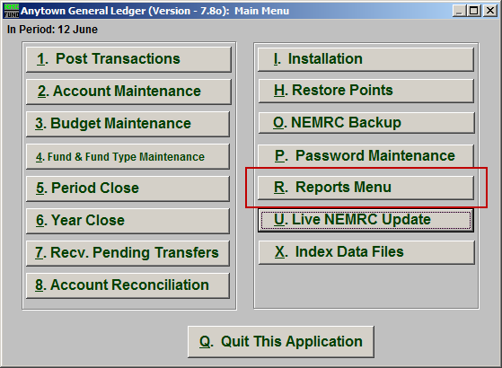
Click on “R. Reports Menu” from the Main Menu and the following window will appear:

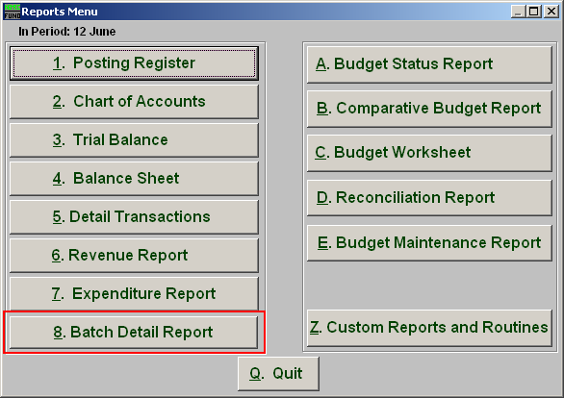
Click on “8. Batch Detail Report” from the Reports Menu and the following window will appear:

Batch Detail Report

The “Transaction Options” tab

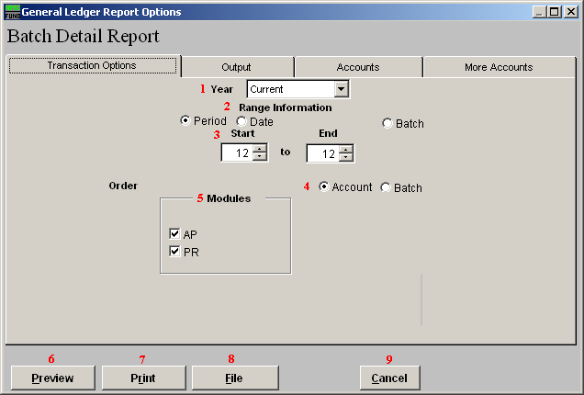

- Year: Type in the Year you want the report be for OR click on the arrow and select from the table.

- Range Information: This report can draw information based on a fiscal period, transaction date or batch number range.

- Start to End: Depending on what you selected for “Range Information” enter in the corresponding start and end values here.

- Order Account OR Batch: Selected data can be organized by the reference account as the primary sort or retain the information group by the given module and batch number assigned by the system.

- Modules: Select one or both of the modules to collect the detail information from regarding your choices from above.

- Preview: Click this button to preview. Refer to GENERAL PREVIEW for more information.

- Print: Click this button to print. Refer to GENERAL PRINTING for more information.

- File: Click this button to save on this computer. Refer to GENERAL FILE for more information.

- Cancel: Click “Cancel” to cancel and return to the previous screen.

The “Output” tab

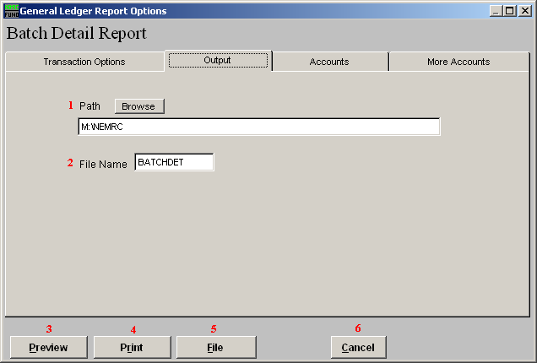

- Path: Type in the location of the folder you wish to save this report in when you export. You may click “Browse” to locate the folder.

- File Name: Type in the name that this report will be saved as.

- Preview: Click this button to preview. Refer to GENERAL PREVIEW for more information.

- Print: Click this button to print. Refer to GENERAL PRINTING for more information.

- File: Click this button to save on this computer. Refer to GENERAL FILE for more information.

- Cancel: Click “Cancel” to cancel and return to the previous screen.

The “Accounts” tab

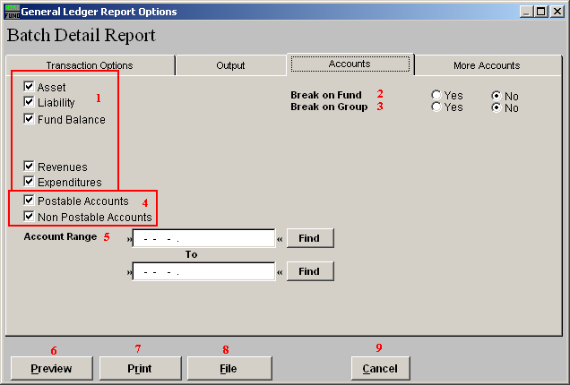
- Account type selection: You can select some or all account types to report detail postings for. The types available are dependant on the design of your chart of accounts.

- Break on Fund: Select “Yes” if you would like a space between Fund accounts.

- Break on Group: Select “Yes” if you would like a space between Group accounts.

- Postable Accounts, Non Postable Accounts: Select the option to include accounts that are presently active (postable) and/or inactive (non-postable). You must select at least one of these two choices.

- Account Range: Type in the Account you want to start with TO the account you want to end with OR click “Find” and select from the table.

- Preview: Click this button to preview. Refer to GENERAL PREVIEW for more information.

- Print: Click this button to print. Refer to GENERAL PRINTING for more information.

- File: Click this button to save on this computer. Refer to GENERAL FILE for more information.

- Cancel: Click “Cancel” to cancel and return to the previous screen.

The “More Accounts” tab

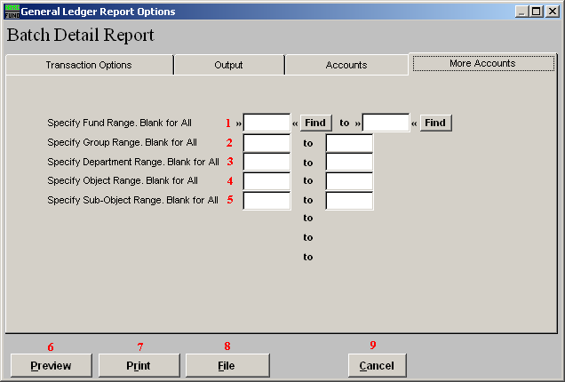
- Specify Fund Range: This option appears for all charts of accounts. Type in a beginning and ending fund number range to further restrict the reporting if desired. Items 2 through 5 will vary according to the design and descriptions for your chart of accounts definitions.

- Specify Group Range: Enter a beginning and ending value range to further restrict the reporting if desired.

- Specify Department Range: Enter a beginning and ending value range to further restrict the reporting if desired.

- Specify Object Range: Enter a beginning and ending value range to further restrict the reporting if desired.

- Specify Sub-Object Range: Enter a beginning and ending value range to further restrict the reporting if desired.

- Preview: Click this button to preview. Refer to GENERAL PREVIEW for more information.
- Print: Click this button to print. Refer to GENERAL PRINTING for more information.

- File: Click this button to save on this computer. Refer to GENERAL FILE for more information.

- Cancel: Click “Cancel” to cancel and return to the previous screen.

